[INTRODUCTORY PARAGRAPH HERE]

Phonation types, more specifically, are the different methods of producing sound through the vibration of the vocal cords (Keating and Esposito 2006: 85). Ladefoged (1971) represented phonation types as falling on a one-dimensional articulatory continuum based on the degree of glottal constriction, an assumption that underlies much of the literature on this topic (e.g. Keating and Esposito 2006, ).

Although this representation is a useful starting point, recent work suggests that multiple dimensions of variation may be necessary to fully describe different phonation types (Keating and Esposito 2006).

Modal

Most closed (glottal closure)

Creaky

Most open (voiceless)

Breathy

[INCLUDE THE TWO-DIMENSIONAL MODEL OF PHONATION TYPES FROM

Creaky voice, for instance, may be best described using three acoustic and physiological factors (Kreiman 2014; Keating, Garellek, and Kreiman 2014; Garellek 2016). Garellek (2016: 8) represents these factors and the resulting types of creaky voice as seen below: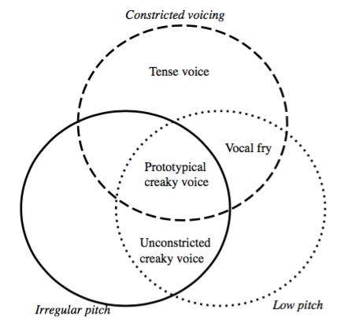

Breathy voice can also result from a combination of different acoustic factors, such as spectral tilt and the harmonics-to-noise ratio, both within and across languages (Keating and Esposito 2006: 86).